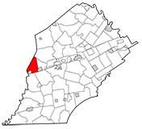

# West Sadsbury Township Planning Commission

**August 27, 2024 – 7:30 PM**

# West Sadsbury Township Building

* **Pledge of Allegiance & Recognition of Visitors/Public Comments on Agenda Items**
* **PC Meetings in June & July were cancelled.**
* **Past Meeting Minutes**
  + **May 28, 2024**
* **Old Business:** 
  + **None**
* **New Business:**
  + **Concerns or Discussion Items**
  + **Resignation of PC Chairman**
* **General Public Comments Regarding Current Projects at the Planning Commission/General Questions on Potential Upcoming Projects**
* **Next Meeting – September 24, 2024, @ 7:30 PM**