On Thursday February 27th around 5:00 am an explosion awoke residents of West Sadsbury Township. Fire crews and emergency personnel worked tirelessly to get the blaze under control, However the house and all contents were a total loss. Thankfully, the family was able to get out safely but now must move forward to rebuild their lives. Please help if you can.

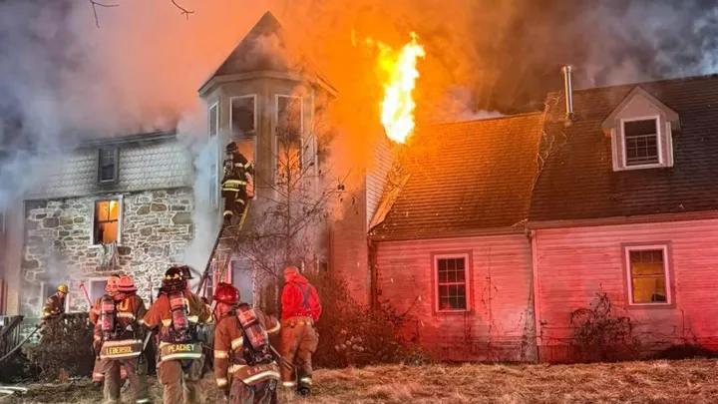

A GoFundMe campaign has been launched to gather funds for them. Every contribution, no matter how small, can help provide the essentials they need to move forward. They lost so much, and while some things can't be replaced, we can assist them in starting anew.  
  
Please take a moment to consider donating or sharing the campaign. Your kindness can help ease their burden during this unimaginable time. Thank you for your support and generosity.  
  
Warm regards,  
  
<https://gofund.me/92d2f892>